CAS PY 106

In-class Note 1

1. What is electricity?
2. Electricity is a large collection of electric charge
3. Matter consists of atoms
4. 1 atom = N electrons + N protons + bunch of neutrons
5. Charge is “quantized”, meaning the total charge is always an integer multiple of e
6. 1 Coulomb (C) is a lot of charge: -1C is n = q/e = -1C / 1.602\*10^-19 C/electron = 6.2415 \* 10^18 electrons
7. Coulomb (C)
8. A neutral object has zero net charge (equal positive and negative charges): 0 C
9. Common prefixes

micro Coulombs: 1uC = 10^-6 C

nano Coulombs: 1nC = 10^-9 C

pico Coulombs: 1pC = 10^-12 C

1. Experiment

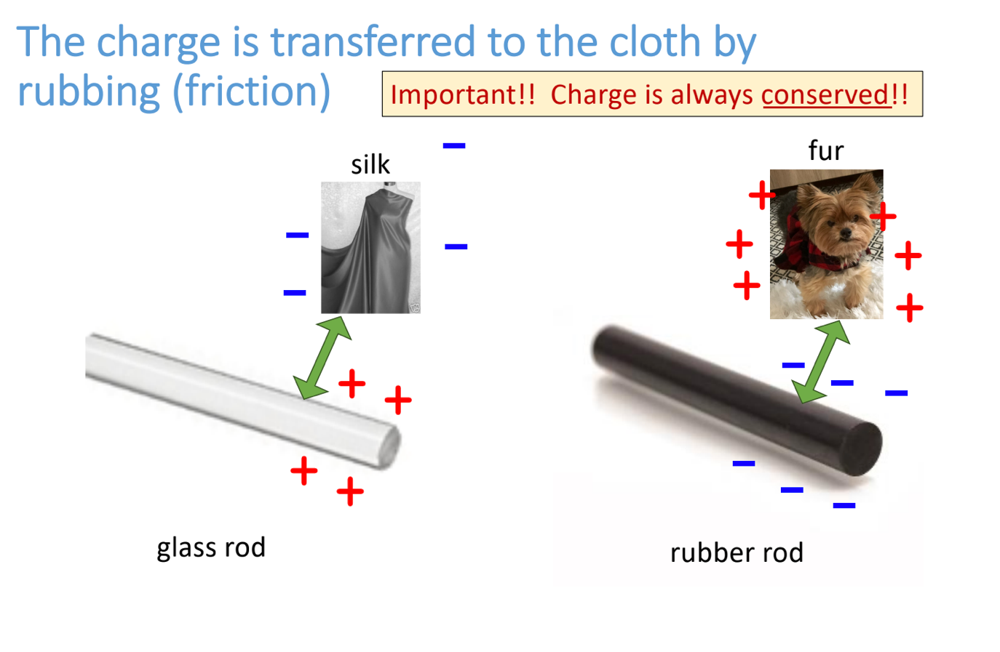

1. The rubbing effect (the “triboelectric effect”) is stronger for some materials than for others
2. While rubbing, chemical bonds between the atoms inside molecules are created and broken, created and broken, and so forth
3. Some materials grab extra electrons from other materials. Materials losing electrons become positive and materials gaining electrons become negative
4. Conductors
5. Metal is an example of a conductor
6. When you put a positive glass rod next to the metal rod without touching, it will be attracted
7. Electrons are free to move inside a metal and these negative charges move to one side, leaving a positive charge behind on the other side
8. This allows metal to be attracted to negative rubber rod as well since the electrons will move away from the rubber rod, leaving only positive and opposite charges naturally attract

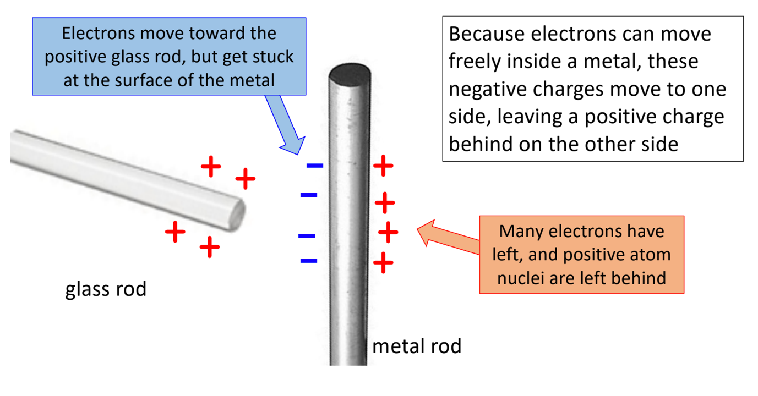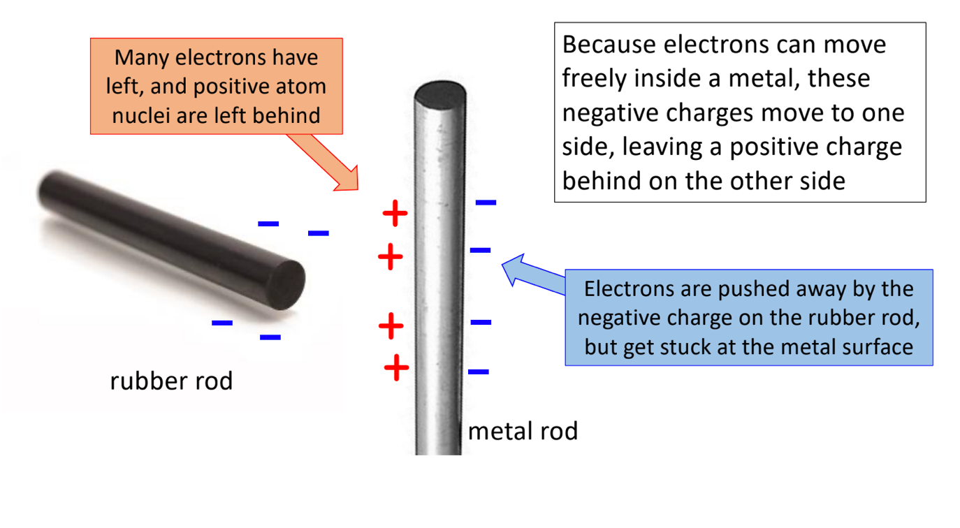

Q) What happens when excess electric charge is placed on the conductor?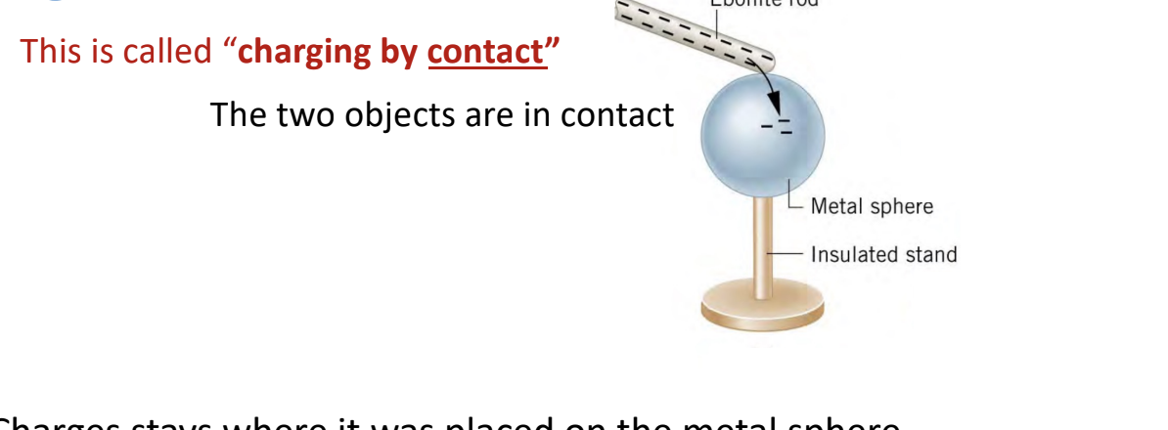

Charge spreads evenly over the whole surface of the metal sphere

The excess electrons repel each other while they move throughout the metal sphere to get as far away as possible – this happens when they all spread evenly over the surface and have nowhere else to go